ADLS Integration with Databricks

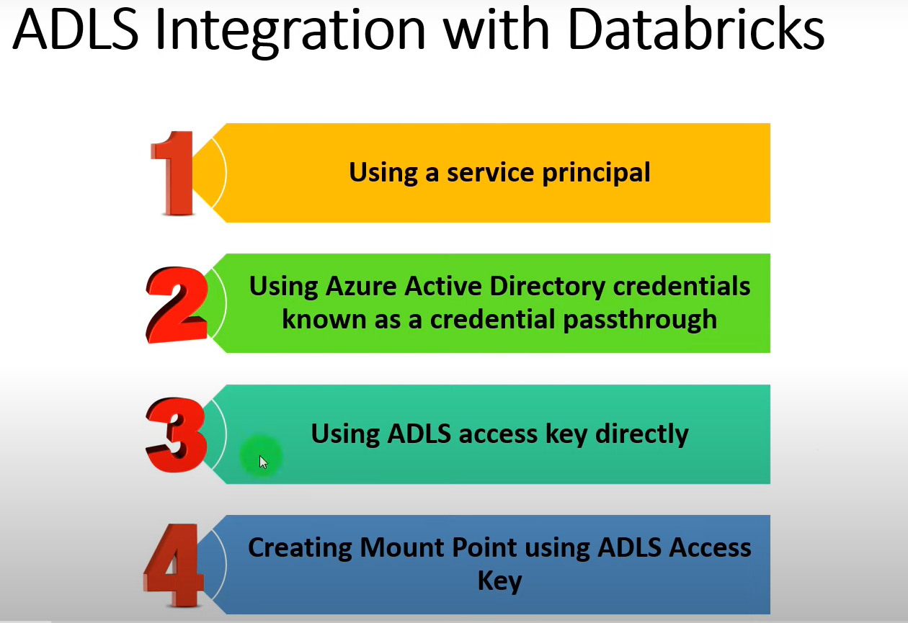

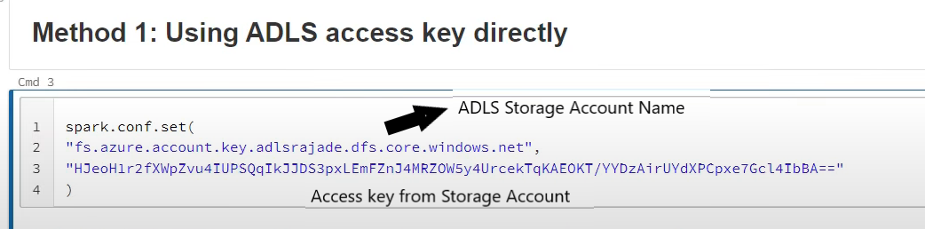

https://lh7-rt.googleusercontent.com/docsz/AD_4nXfeGCa4dzjY4pWnYdYNyXrBQTGmmOQps1pSQYYQ2OywAIpnr56I6metbzaT1Ukdf1TomG1JfWsNSNLiLH2Om-NjI0Y8l-6tk57vNq2y5YsatQXwp6zjAw4ENqOz5G4G2nJqcw0jS5mAumF2cQb4I8lmkezw?key=5-UzcStZXxBX00DSXnl4pA

Access using containername@adlsstorageacctname

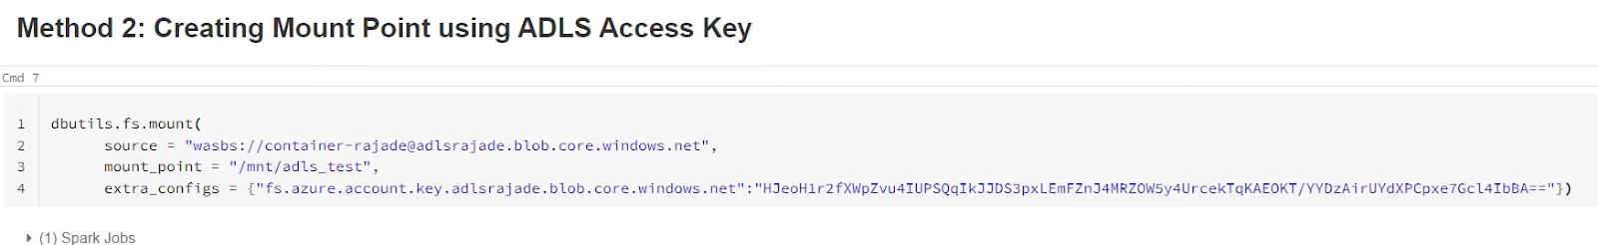

Mount_point path we give as a free text which points to adls container.

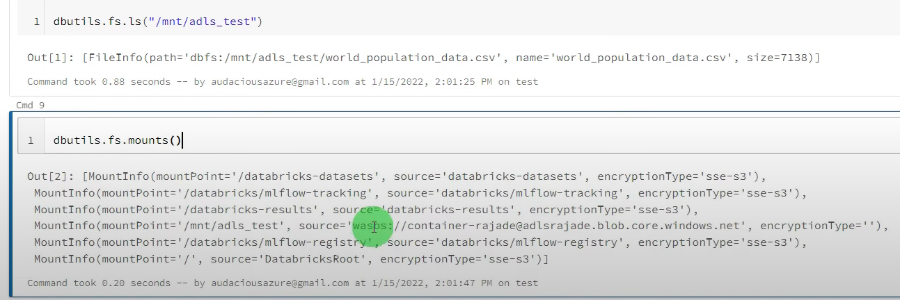

In Databricks notebook

display(dbutils.fs.mounts())

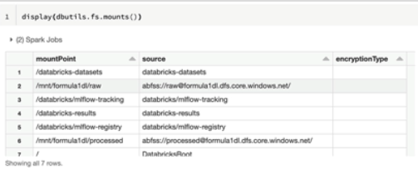

Get the file name under your raw directory

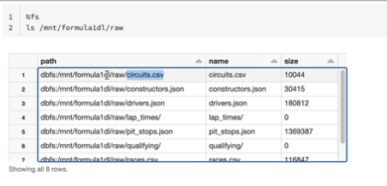

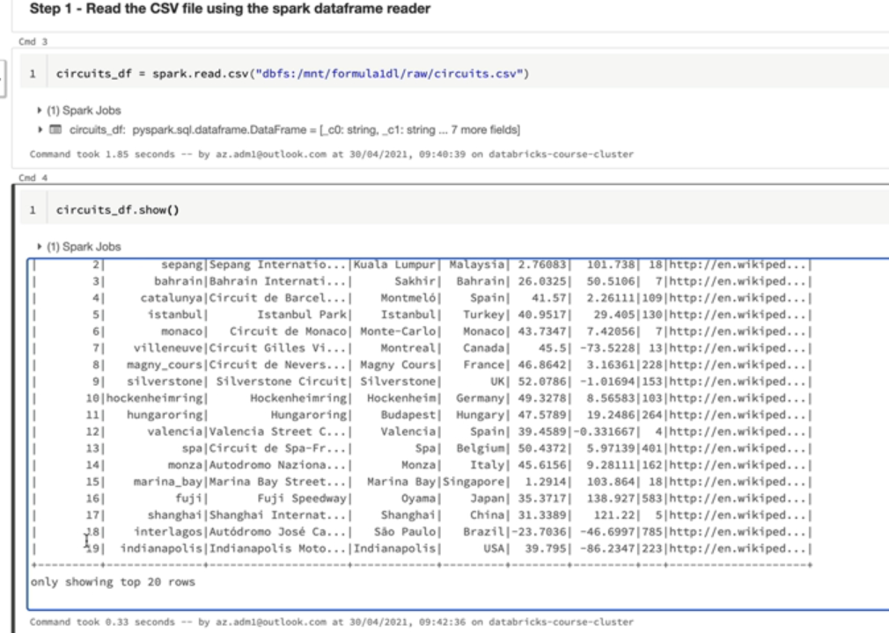

show()  (pyspark method) method shows 20 records,  if not specified in its parameters. Also column data length truncated to 20 chars size.